Assignment: SQL Notebook for Peer Assignment
Estimated time needed: 60 minutes.

Introduction
Using this Python notebook you will:
- Understand the Spacex DataSet
- Load the dataset into the corresponding table in a Db2 database
- Execute SQL queries to answer assignment questions

Overview of the DataSet
SpaceX has gained worldwide attention for a series of historic milestones.
It is the only private company ever to return a spacecraft from low-earth orbit, which it first accomplished in December 2010. SpaceX advertises Falcon 9 rocket launches on its website with a cost of 62 million dollars wheras other providers cost upward of 165 million dollars each, much of the savings is because Space X can reuse the first stage.
Therefore if we can determine if the first stage will land, we can determine the cost of a launch.
This information can be used if an alternate company wants to bid against SpaceX for a rocket launch.
This dataset includes a record for each payload carried during a SpaceX mission into outer space.

Download the datasets
This assignment requires you to load the spacex dataset.
In many cases the dataset to be analyzed is available as a .CSV (comma separated values) file, perhaps on the internet. Click on the link below to download and save the dataset (.CSV file):
Spacex DataSet

!pip install sqlalchemy==1.3.9

Connect to the database
Let us first load the SQL extension and establish a connection with the database
!pip install ipython-sql
!pip install ipython-sql prettytable

%load_ext sql
The sql extension is already loaded. To reload it, use:
%reload_ext sql

import csv, sqlite3
import prettytable
prettytable.DEFAULT = 'DEFAULT'

con = sqlite3.connect("my_data1.db")
cur = con.cursor()

!pip install -q pandas
%sql sqlite:///my_data1.db
import pandas as pd
df = pd.read_csv("https://cf-courses-data.s3.us.cloud-object-storage.appdomain.cloud/IBM-DS0321EN-SkillsNetwork/labs/module_2/data/Spacex.csv")
df.to_sql("SPACEXTBL", con, if_exists='replace', index=False,method="multi")
101

Note:This below code is added to remove blank rows from table

#DROP THE TABLE IF EXISTS
%sql DROP TABLE IF EXISTS SPACEXTABLE;
* sqlite:///my_data1.db
Done.
[]

%sql create table SPACEXTABLE as select * from SPACEXTBL where Date is not null
* sqlite:///my_data1.db
Done.
[]

%sql SELECT * FROM SPACEXTABLE LIMIT 8;
* sqlite:///my_data1.db
Done.

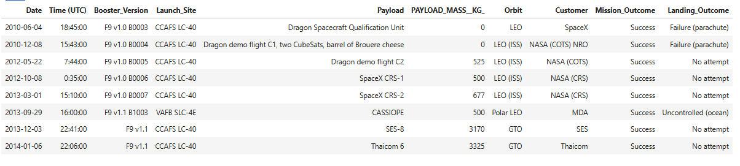

Tasks
Now write and execute SQL queries to solve the assignment tasks.
Note: If the column names are in mixed case enclose it in double quotes For Example "Landing_Outcome"

Task 1

Display the names of the unique launch sites in the space mission
%sql SELECT DISTINCT Launch_Site FROM SPACEXTABLE;
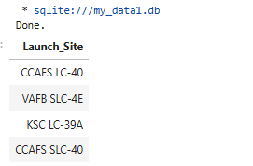

Task 2

Display 5 records where launch sites begin with the string 'CCA'
%sql SELECT * FROM SPACEXTABLE where Launch_Site like 'CCA%' LIMIT 5;
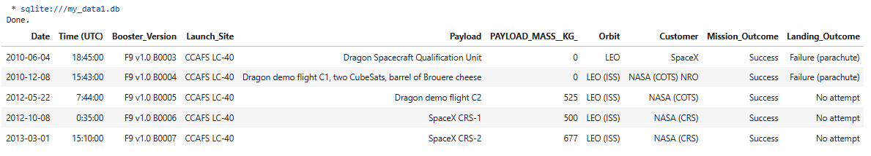

Task 3

Display the total payload mass carried by boosters launched by NASA (CRS)¶

#%sql SELECT name,type,length(type) FROM PRAGMA_TABLE_INFO('SPACEXTABLE');
%sql SELECT SUM(PAYLOAD_MASS__KG_) FROM SPACEXTABLE where Customer = 'NASA (CRS)'
* sqlite:///my_data1.db
Done.
SUM(PAYLOAD_MASS__KG_)
45596

Task 4

Display average payload mass carried by booster version F9 v1.1
%sql SELECT AVG(PAYLOAD_MASS__KG_) FROM SPACEXTABLE where Booster_Version = 'F9 v1.1'
* sqlite:///my_data1.db
Done.
AVG(PAYLOAD_MASS__KG_)
2928.4

Task 5

List the date when the first succesful landing outcome in ground pad was acheived.
Hint:Use min function
%sql SELECT min(Date) FROM SPACEXTABLE where Landing_Outcome = 'Success (ground pad)'
* sqlite:///my_data1.db
Done.
min(Date)
2015-12-22

Task 6

List the names of the boosters which have success in drone ship and have payload mass greater than 4000 but less than 6000¶
%sql SELECT Booster_Version FROM SPACEXTABLE where Landing_Outcome = 'Success (drone ship)' and PAYLOAD_MASS__KG_ between 4000 and 6000
* sqlite:///my_data1.db
Done.
Booster_Version
F9 FT B1022
F9 FT B1026
F9 FT B1021.2
F9 FT B1031.2

Task 7

List the total number of successful and failure mission outcomes
%sql SELECT trim(Mission_Outcome), Count(1) from SPACEXTABLE group by trim(Mission_Outcome)
* sqlite:///my_data1.db
Done.
trim(Mission_Outcome) | Count(1)
Failure (in flight) | 1
Success | 99
Success (payload status unclear) | 1

Task 8

List all the booster_versions that have carried the maximum payload mass, using a subquery with a suitable aggregate function.

%sql SELECT Booster_Version FROM SPACEXTABLE where PAYLOAD_MASS__KG_ = (select max(PAYLOAD_MASS__KG_) from SPACEXTABLE)
* sqlite:///my_data1.db
Done.
Booster_Version
F9 B5 B1048.4
F9 B5 B1049.4
F9 B5 B1051.3
F9 B5 B1056.4
F9 B5 B1048.5
F9 B5 B1051.4
F9 B5 B1049.5
F9 B5 B1060.2
F9 B5 B1058.3
F9 B5 B1051.6
F9 B5 B1060.3
F9 B5 B1049.7

Task 9

List the records which will display the month names, failure landing_outcomes in drone ship ,booster versions, launch_site for the months in year 2015.
Note: SQLLite does not support monthnames. So you need to use substr(Date, 6,2) as month to get the months and substr(Date,0,5)='2015' for year.

%sql SELECT substr(Date, 6,2) as month, Landing_Outcome, Booster_Version, launch_site FROM SPACEXTABLE where substr(Date,0,5)='2015' and Landing_Outcome = 'Failure (drone ship)'
* sqlite:///my_data1.db
Done.
month | Landing_Outcome | Booster_Version | Launch_Site
01 | Failure (drone ship) | F9 v1.1 B1012 | CCAFS LC-40
04 | Failure (drone ship) | F9 v1.1 B1015 | CCAFS LC-40

Task 10

Rank the count of landing outcomes (such as Failure (drone ship) or Success (ground pad)) between the date 2010-06-04 and 2017-03-20, in descending order.¶

%sql SELECT Landing_Outcome, count(1) as Outcome_Count FROM SPACEXTABLE WHERE Date BETWEEN '2010-06-04' AND '2017-03-20' group by Landing_Outcome order by Outcome_Count desc
* sqlite:///my_data1.db
Done.
Landing_Outcome | Outcome_Count
No attempt | 10
Success (drone ship) | 5
Failure (drone ship) | 5
Success (ground pad) | 3
Controlled (ocean) | 3
Uncontrolled (ocean) | 2
Failure (parachute) | 2
Precluded (drone ship) | 1

Reference Links
- Hands-on Lab : String Patterns, Sorting and Grouping
- Hands-on Lab: Built-in functions
- Hands-on Lab : Sub-queries and Nested SELECT Statements
- Hands-on Tutorial: Accessing Databases with SQL magic
- Hands-on Lab: Analyzing a real World Data Set

